

Derby and Derbyshire Brain Health Toolkit
Dissemination plan 2026
Author: Lorraine Stokes Version 1
Derby and Derbyshire Brain Health Toolkit

Background
Dementia is one of the most significant public health challenges facing the UK, with prevalence expected to rise as the population ages. While age remains the strongest known risk factor, extensive national and international research shows that up to 45% of dementia cases may be preventable or delayable through action on modifiable risk factors across the life course. These risk factors include physical inactivity, smoking, poor cardiovascular health, social isolation, hearing loss, and unmanaged long-term conditions, among others. This growing evidence base has strengthened the national policy focus on brain health—an approach that encourages people to understand, protect, and maintain their cognitive wellbeing throughout life.
Brain Health refers to the ability to think, learn, and remember, and is influenced by lifestyle, environment, and overall physical health. In the context of dementia risk reduction, promoting brain health means increasing public awareness of the steps that individuals and communities can take to reduce their risk and support healthier ageing. This approach aligns with national priorities outlined by the Association of Directors of Public Health (ADPH), the Office for Health Improvement and Disparities (OHID), and the NHS, all of which advocate stronger prevention and early intervention to reduce future dementia burden.
Need for a Derby and Derbyshire Brain Health Toolkit
National evidence clearly highlights that public awareness of dementia risk reduction remains low, despite the strength of the scientific evidence. This was reinforced locally during the Derbyshire Dementia Strategy engagement process, where insight gathering with residents, carers, professionals, and community groups showed a strong need for:
- clearer public messaging about brain health
- practical, accessible resources for professionals
- consistent, evidence-based information across sectors
These findings aligned with national evidence and provided a compelling case for a coordinated local approach to awareness-raising and prevention.
Development of the Toolkit
In response, the Derby and Derbyshire Brain Health Toolkit has been developed to support consistent, evidence-informed communication and action across the system. The toolkit has been created collaboratively through the Derbyshire Dementia Risk Reduction Subgroup, bringing together partners from health, social care, public health, voluntary and community sector organisations, and local authorities. Crucially, the development process has also included input from the Derbyshire Dementia Co-production Group, ensuring that lived experience has shaped both the content and the approach.
The toolkit provides a unified set of messages, resources, and guidance to help professionals—and the wider community—understand and promote the factors that can protect brain health and reduce dementia risk. This dissemination plan supports its launch and aims to drive awareness, consistency, and adoption across Derby and Derbyshire.

Overall Aims
- Increase awareness and understanding of Brain Health across Derby and Derbyshire, with a focus on how lifestyle factors influence dementia risk across the life course.
- Promote the Derby & Derbyshire Brain Health Toolkit as the central, trusted local resource for evidence-informed dementia risk reduction information and messaging.
- Support system-wide consistency by encouraging all partners to use the same language, evidence base, and tools when discussing brain health and dementia risk reduction.
- Strengthen prevention efforts by equipping professionals, communities, and organisations with accessible resources to support behaviour change and healthier ageing.
- Amplify the voice of lived experience by recognising and promoting the role of the Derbyshire Dementia Co-production Group in shaping toolkit content and priorities.

Overall Objectives
Awareness & Engagement
- Raise public awareness that up to 45% of dementia cases may be preventable or delayable through modifiable risk factors.
- Increase understanding of the connection between general health, healthy ageing, and brain health.
- Ensure residents know where to find the toolkit and how to use its resources.
Professional Use & Adoption
- Encourage professionals across health, social care, VCSE, local authorities, and education to adopt the toolkit in routine practice.
- Provide clear, consistent resources for frontline staff to support conversations about dementia risk reduction.
- Equip non-specialist staff with simple, practical messages for raising awareness.
System Collaboration & Consistency
- Promote cross-sector collaboration by showcasing that the toolkit was created through the Derbyshire Dementia Risk Reduction Subgroup with co-production involvement.
- Align local communication on dementia risk reduction with national evidence and messaging (OHID, NHS, Alzheimer’s Society, research consortia).
Behaviour Change & Prevention Impact
- Encourage residents to take positive steps that protect brain health (e.g., being active, stopping smoking, managing hearing loss, staying socially connected).
- Support communities and organisations in embedding brain-healthy environments, messages, and interventions.
- Contribute to long-term reductions in modifiable dementia risk across Derby and Derbyshire.
Evaluation & Improvement
- Monitor uptake and usage of the toolkit by professionals and partner organisations.
- Gather feedback from communities and people with lived experience to help refine and develop future iterations of the toolkit.
- Track reach, engagement, and shifts in local understanding of dementia risk reduction as part of ongoing strategy delivery.

Communications objectives:
- Increase public understanding of brain health by clearly explaining how everyday lifestyle choices—such as physical activity, smoking, alcohol use, social connection, hearing health, diet, and cardiovascular wellbeing—can influence long-term cognitive health and dementia risk.
- Promote simple, achievable actions people can take at any age to protect their brain health, using clear, consistent, and motivating messages drawn from the Brain Health Toolkit.
- Raise awareness of local services, resources, and community support that can help people make positive lifestyle changes, manage long-term conditions, and stay connected- highlighting the practical support available across Derby and Derbyshire.
- Encourage professionals and community organisations to embed brain-health messaging in their everyday conversations, signposting, and interventions, ensuring consistent and evidence-based communication across the system.
- Build confidence among residents and professionals by positioning the Brain Health Toolkit as a trusted, accessible, and co-produced resource created specifically to support local prevention efforts.

Purpose of this dissemination plan
The purpose of this dissemination plan is to ensure the Derby and Derbyshire Brain Health Toolkit is widely promoted, easily understood, and confidently used by professionals, partners, and communities. It aims to raise awareness of brain health and dementia risk reduction, ensuring people know what the toolkit is, when to use it, and how to use it effectively in different settings.
Through coordinated, accessible communication, the plan supports efforts to reduce health inequalities by making high-quality, evidence-informed resources available to all communities, including those at greater risk of poor health outcomes. By increasing knowledge, confidence, and consistency across the system, this plan seeks to maximise the toolkit’s reach and impact—helping more people take positive steps to protect their brain health and reduce their risk of dementia.

Supporting Messages
- The Brain Health Toolkit is simple, practical, and grounded in robust evidence, making it easy for anyone to use in everyday conversations and professional practice.
- It is not a new service or additional workload—it enhances and supports the prevention and wellbeing work that professionals and community partners already do.
- Using the toolkit strengthens system-wide priorities, including prevention, healthier ageing, and reducing health inequalities across Derby and Derbyshire.
- Even small, brief conversations about brain health can have a meaningful impact on someone’s future wellbeing, helping people take early, achievable steps that protect their cognitive health.
- Everyone has a role to play—not just health professionals. Community groups, volunteers, social care, education, and local services can all help make brain-healthy messages part of everyday life.

Introductory content for dissemination email
Hello,
We’re excited to share the new Derby and Derbyshire Brain Health Toolkit—a simple, practical resource anyone can use to learn about brain health and support dementia risk reduction.
The toolkit offers clear, evidence-based messages and easy actions people can take at any age. It’s there to help you support your own wellbeing and to make it easier to talk about brain health with others in your networks, services, groups, or day-to-day conversations.
We’d love you to:
- use the toolkit yourself,
- share it with others, and
- include its messages in your conversations, meetings, and activities.
You can access the toolkit here: https://jsnaderbyshire.org.uk/bhtk/
Thank you for helping to spread simple, positive steps that support better brain health for everyone.
Best wishes,
[insert sender]

Add promotional materials- email banner etc.

Key stakeholders and delivery groups
Partner | Contact information | Contacted?
Health & care System Partners
NHS Derby & Derbyshire Integrated Care Board (ICB) | Contact through Claire Biernacki
Derbyshire County Council – Public Health | Contact through Lorraine Stokes
Derby City Council – Public Health | Contact through Allan Reid and Angela Odell
Derbyshire Healthcare NHS Foundation Trust | Contact through Claire Biernacki
University Hospitals of Derby and Burton NHS Foundation Trust | Contact through Claire Biernacki
Chesterfield Royal Hospital NHS Foundation Trust | Contact through Claire Biernacki
Primary Care Networks (PCNs) | Contact through Claire Biernacki
GP practices and practice nurses | Contact through Claire Biernacki
Health Visitors & School Nurses | Contact through Claire Biernacki
Community Nursing teams | Contact through Claire Biernacki
Allied Health Professionals (AHPs)- Pharmacists? Dieticians? | Contact through Claire Biernacki
Mental health practitioners | Contact through Suicide and Mental Health PH team
Health and social care commissioners | Contact through Claire Biernacki
Drug & alcohol services | Contact through Alcohol & Drugs PH team
Learning disability & autism services | Contact through Claire Biernacki
Adult Social Care & Support Services
Derbyshire County Council Adult Social Care | Contact through Phil Wall
Derby City Council Adult Social Care | Contact through Michael Rose
Community navigators / social prescribers | Contact through Community Support & Resilience PH team
Voluntary, Community & Social Enterprise (VCSE) Sector

Alzheimer’s Society (Derbyshire and Derby City teams) | Contact through Susan O’Malley
Age UK Derby & Derbyshire | Contact through Katy Pugh
Derbyshire Carers Association | Contact through Katy Pugh
Derbyshire Mind | Contact through Katy Pugh
Local community centres and hubs | Contact through Katy Pugh
Social connection groups | Contact through Katy Pugh
CVS’ | Contact through Katy Pugh
Active Derbyshire | Contact through Sam Elks
Refugee/migrant support teams- Refugee and asylum seeker services | Contact through Community Support & Resilience PH team
Underserved communities- Faith Groups, GRT, LGBTQ+ | Contact through Public Health Localities
Prevention & Healthy Lifestyle Services

Live Life Better Derbyshire | Contact through Sam Elks
Livewell Derby | Contact through Angela Odell
Hearing services and audiology providers | Contact through Phil Wall
Falls prevention services | Contact through Katy Pugh
Education, Training & Workforce Partners

Education settings (Schools / academies / PRU/ Specialist, colleges, universities) | Need info
Derbyshire Constabulary and Derbyshire Fire & Rescue Service (community safety and prevention roles) | Need info
Adult community education providers | Need info
Corporate and workplace wellbeing teams | Contact through Ann Lewis
Local Community Networks & Informal Groups

Parish, Town, Borough, District Councils | Contact through Public Health Localities
Libraries | Contact through Claire Moore
U3A (University of the Third Age) | Contact through Katy Pugh
50+ Forums | Contact through Sarah Skinner
Safe Spaces | Contact through Health & Wellbeing Team
People with Lived Experience & Co-Production Partners

Derbyshire Dementia Co-Production Group | Contact through Phil Wall
Healthwatch Derbyshire | Contact through Helen Aldridge
JUCD Patient Participation Groups | Contact through Claire Biernacki
Strategic Groups & Boards

Derbyshire Dementia Strategic Partnership Group and Implementation Partnership | Contact through Claire Biernacki
Health & Wellbeing Boards (Derby and Derbyshire) | Contact through Lorraine Stokes and Allan Reid
Neighbourhood (Place) Partnerships | Contact through Claire Biernacki and Allan Reid
The Mental Health, Learning Disabilities and Autism Delivery Board | Contact through Claire Biernacki

Ideas for how to disseminate to audiences

Activity | Dissemination leads | Timescale | Cost | Completed?
Take to Derbyshire Dementia Co-production Group. Add endorsement logo. | Phil Wall | March 2026 | Subgroup members time | Yes
Derbyshire County Council  - Our Derbyshire  - Connect  - PH newsletter  - ASC newsletter  - Locality Leads  - Take to DCC Public Health Monthly Briefing | Strategic Intent  Colleen Marples  Lorraine Stokes  Dale Burton  Phil Wall | Public Health Briefing- 15/04/2026 | Subgroup members time
Derby City Council | Allan Reid  Angela Odell |  | Subgroup members time
Share on GP screens  Pathfinder? | Phil Wall |  | Subgroup members time
Put posters in staff areas.  Share regular reminders via email, chat channels, or team updates. | All |  | Subgroup members time
Push out the toolkit through all major Derbyshire system bulletins to professionals | Colleen Marples  Chloe Cannon |  | Subgroup members time
Schools Net - Derbyshire | schoolsnet@derbyshire.gov.uk |  | Subgroup members time
Info to district, borough, parish and town councils | ? |  | Subgroup members time
Info to VCSE | Katy Pugh |  | Subgroup members time
BBC Radio Derby | Katy Pugh & Susan O’Malley |  | Subgroup members time
Derbyshire Dementia Podcast | Phil Wall |  | Subgroup members time
Share updated Easy Read | Lorraine Stokes | May 2026 | Subgroup members time
Share with ARUK | Lorraine Stokes |  | Subgroup members time
Share with Karen Dodd | Lorraine Stokes |  | Subgroup members time | Yes
Ensure services listed in signposting is aware of toolkit | Lorraine Stokes & Louise Hall |  | Subgroup members time
Article in JUCD newsletter | Claire Biernacki
Email banners etc. | Dale Burton |  |  | Yes
Evaluation plan & survey | Dale Burton & Lorraine Stokes

Timescales / key dates
Full launch for Dementia Action Week- 18th May 2026

Evaluation
- Insights from feedback form
- Online usage stats
- ?

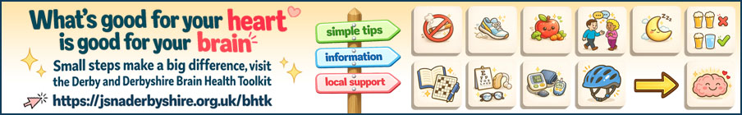
Email signature:
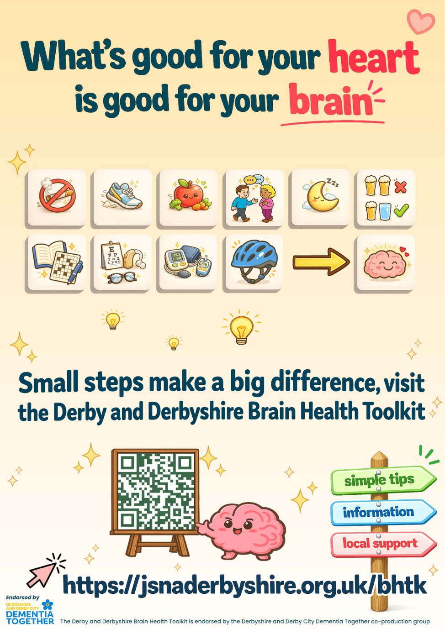
Optional poster:
