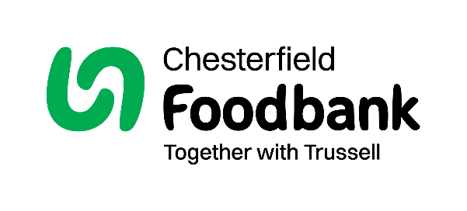
Gift Aid Form

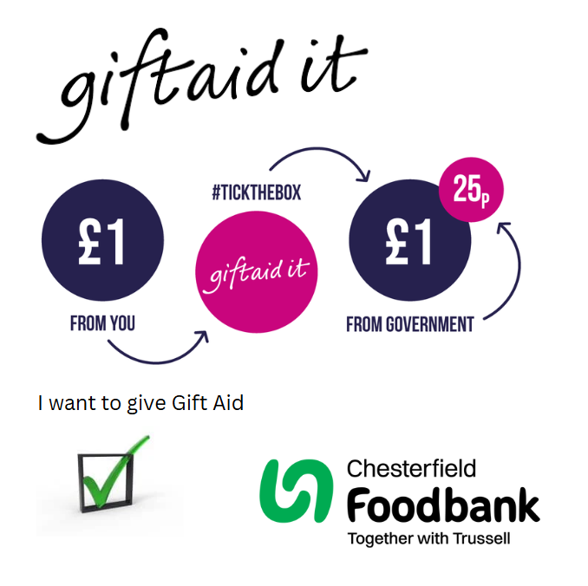
By filling in this form Chesterfield Foodbank will receive an extra 25p for every £1 you give at no extra cost to you. Thank you!

Mr/Mrs/Miss/Ms Click or tap here to enter text.
Name:Click or tap here to enter text.
Address:Click or tap here to enter text.
Postcode:Click or tap here to enter text.
Phone:Click or tap here to enter text.
Email:Click or tap here to enter text.

Boost your donation by 25p of Gift Aid for every £1 you donate
☐ I want to Gift Aid my donation and any donations I make in the future or have made in the past four years.
I am a UK Taxpayer and understand that if I pay less Income Tax and/or Capital Gains Tax than the amount of Gift Aid claimed on all my donations in that tax year it is my responsibility to pay any difference.
Date:Click or tap here to enter text.
We would love to keep in touch with you so we can update you on our work.
Please tick here if you would be happy to receive communications from us:
☐By Post ☐By Email ☐I do not wish to receive future communications from Chesterfield Foodbank

You can change your preferences any time by contacting us on 07529224996 or emailing us at info@chesterfield.foodbank.org.uk

Data Protection
Chesterfield Foodbank is committed to protecting your privacy and will process your personal data in accordance with current Data Protection legislation. Chesterfield Foodbank collects information to keep in touch with you and supply you with information relating to our work. To unsubscribe from our newsletter, send a message to the email address above with the word unsubscribe in the subject line. A full data privacy statement for financial donors is available from the foodbank on request.

We would love to know why you have chosen to donate to Chesterfield Foodbank. If you would like to share your motivation let us know below:
Click or tap here to enter text.

