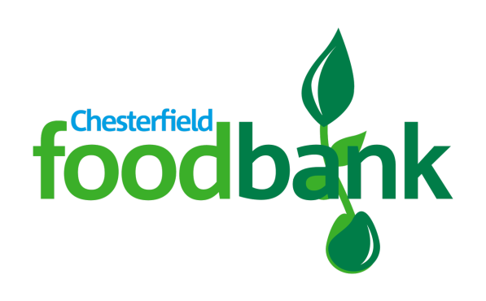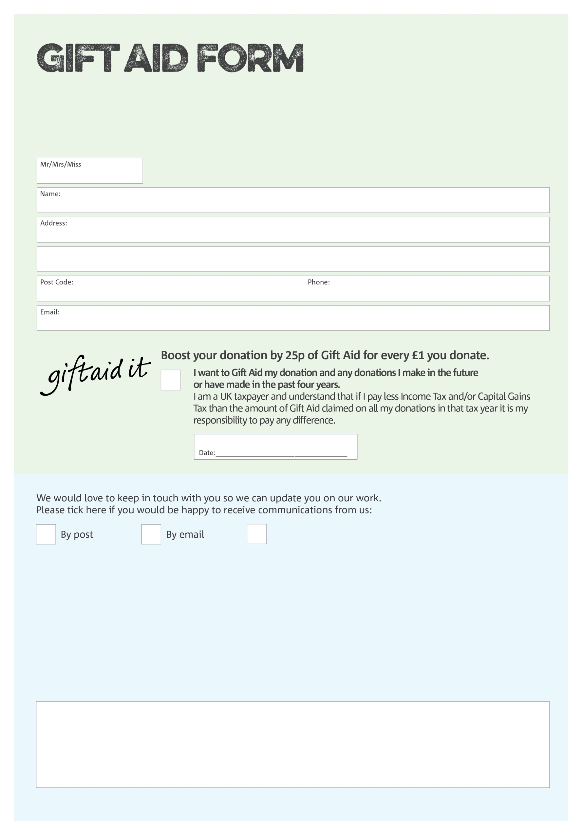

By filling in this form Chesterfield Foodbank will receive an extra 25p for every £1 you give at no extra cost to you. Thank you!

You can change your preferences any time by contacting us on 07984 589456 or emailing us at

info@chesterfield.foodbank.org.uk

I do not wish to receive future communications from Chesterfield Foodbank

**Data protection**

Chesterfield Foodbank is committed to protecting your privacy and will process your personal data in accordance with the Data Protection Act 1998. Chesterfield Foodbank collects information to keep in touch with you and supply you with information relating to our work. Chesterfield Foodbank will never sell or pass your details to anyone who isn’t directly working on our behalf.

We would love to know why you have chosen to donate to Chesterfield Foodbank. If you would like to share your motivation let us know below:

Reg. Charity No: 1174426 | Reg. in England & Wales