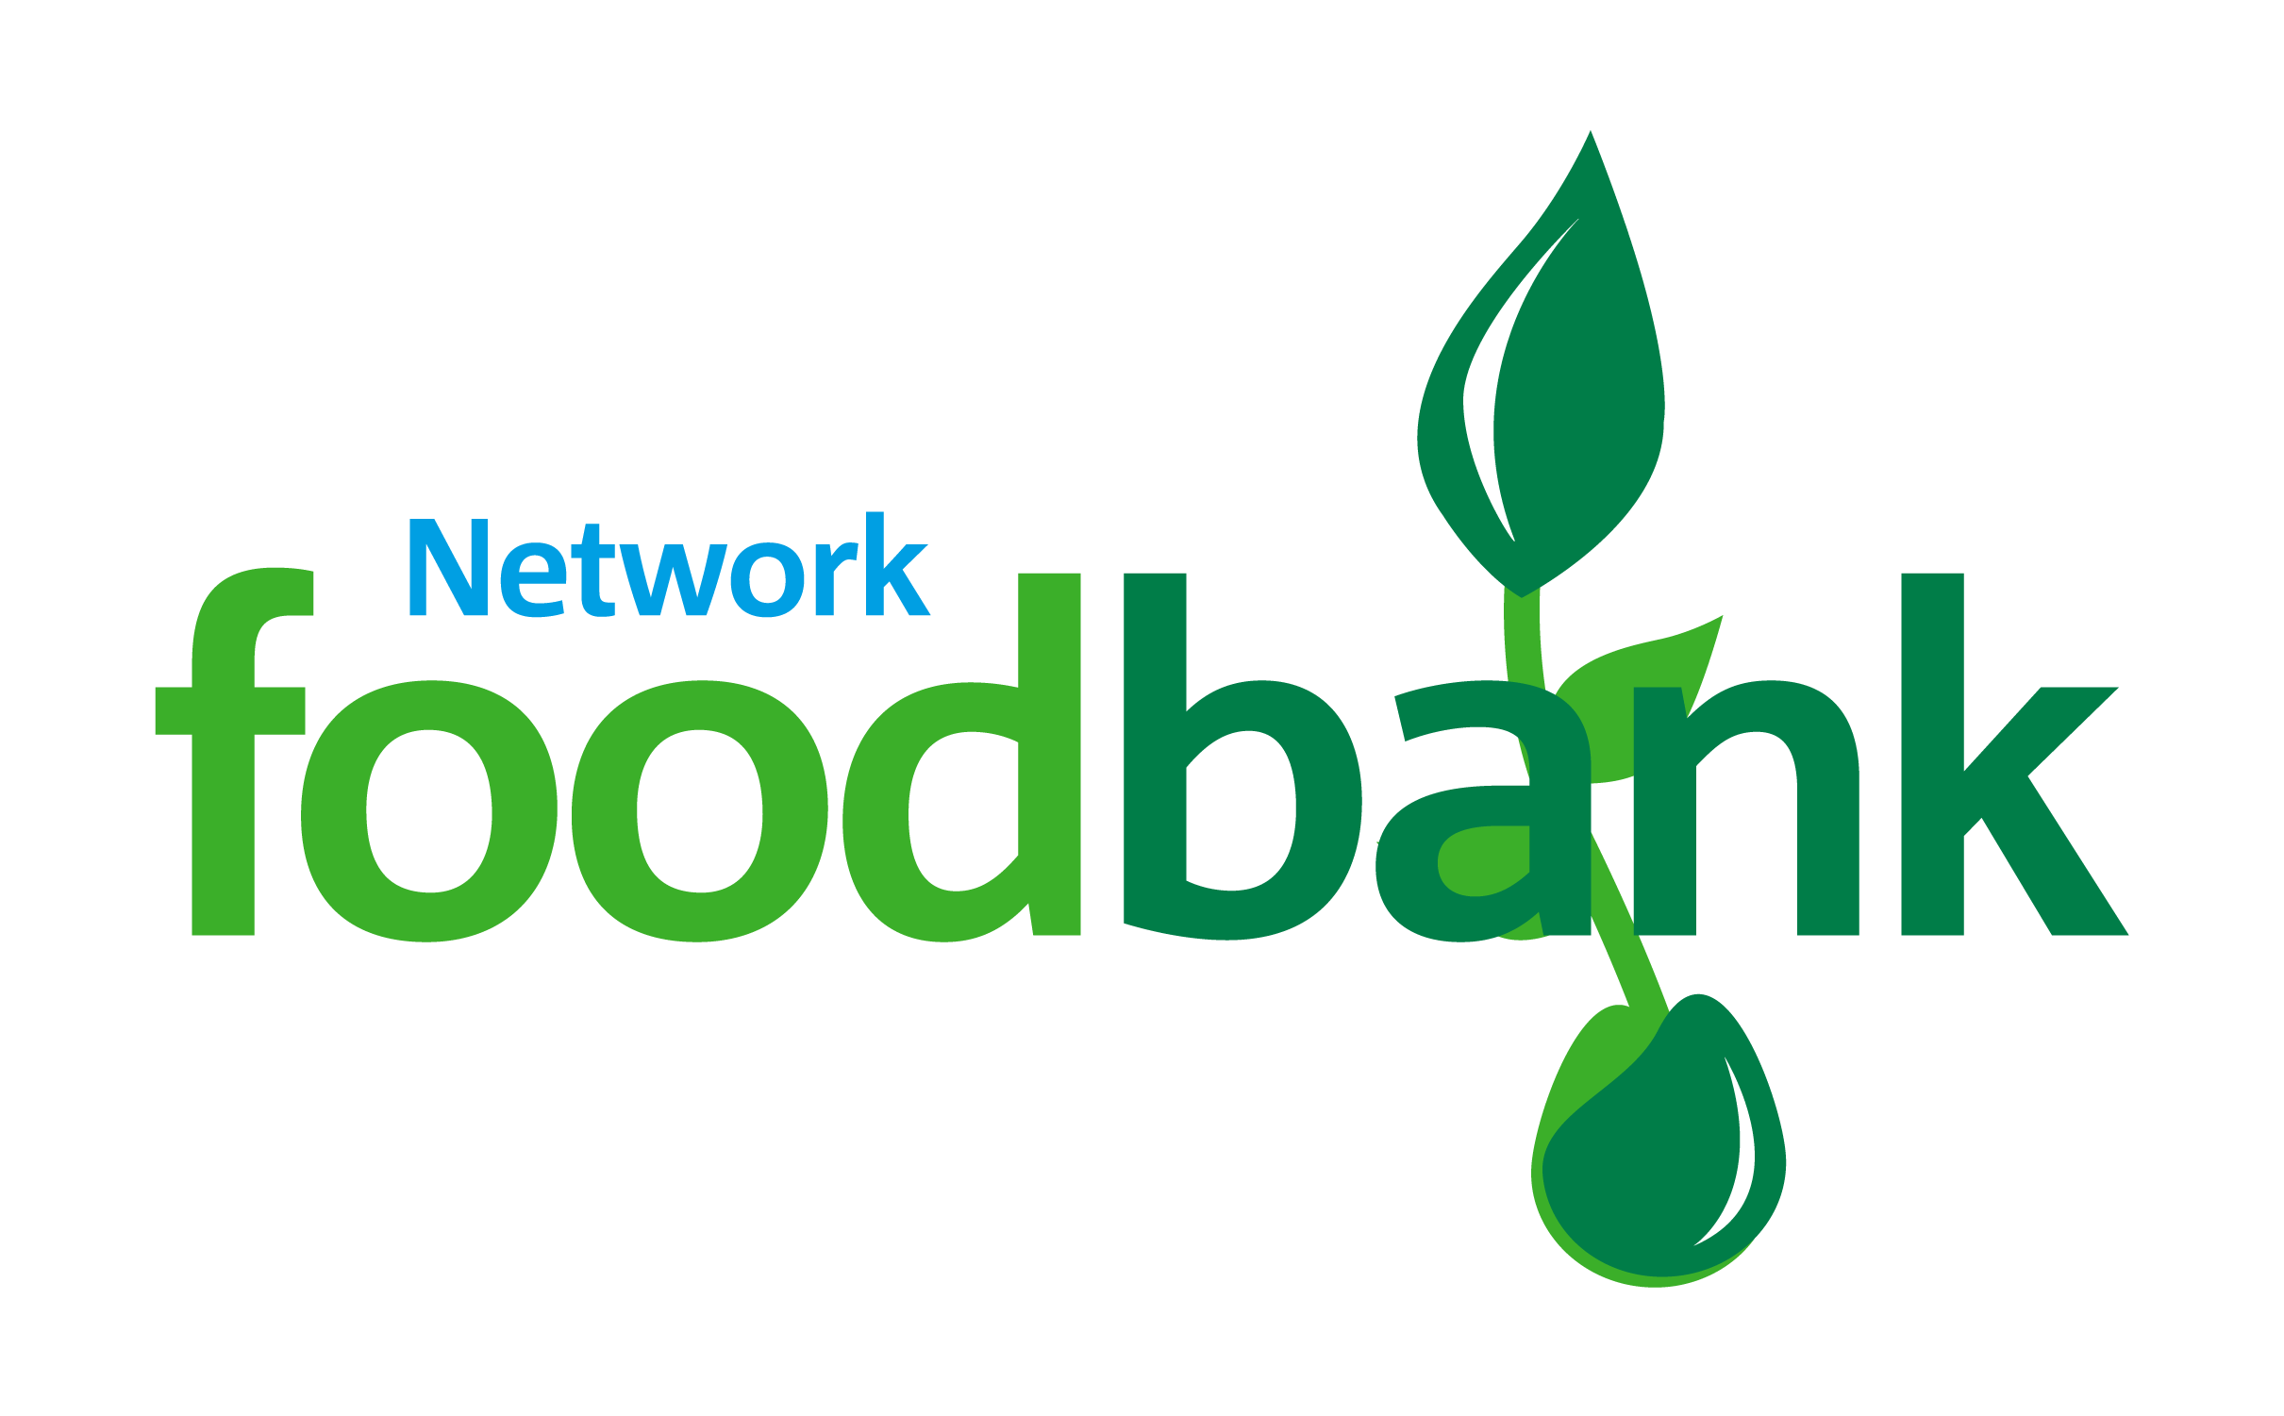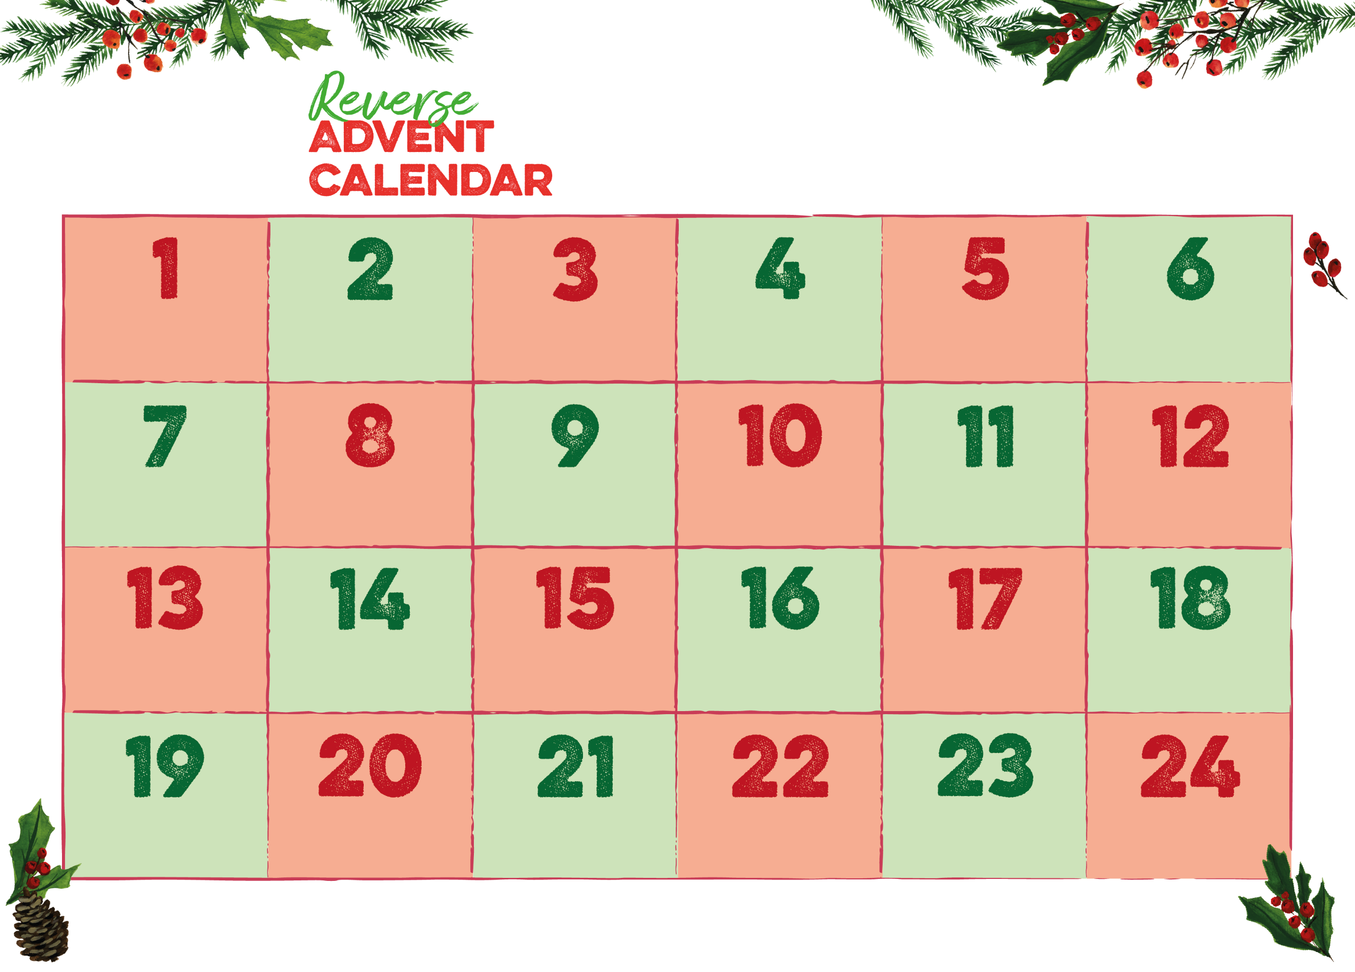

Registered Charity in England & Wales (1174426)

**chesterfield.foodbank.org.uk**

**Please contact us to find out our opening times around Christmas and to check if there is anything, we’re running short of.**

**Our email address is** [**info@chesterfield.foodbank.org.uk**](mailto:info@chesterfield.foodbank.org.uk) **and our  
telephone number is 07984 589456**

**Tinned Vegetables**

**Chocolate**

**Sponge Puddings**

**Jars of Jam**

**Packs of Biscuits**

**Long Life Juices**

**Tinned Rice**

**Tinned Fruit**

**UHT Milk**

**Jars of Coffee**

**Packets of Tea**

**Cereals**

**Tins of Soup**

**Dried Sauces**

**Instant Mash**

**Dried Rice**

**Pasta Sauce**

**Dried Pasta**

**Tinned Fish**

**Tinned Meat**

**Tinned Spaghetti**

**Tinned Beans**

**Tinned Tomatoes**

**Toiletries**