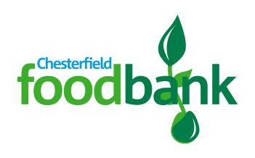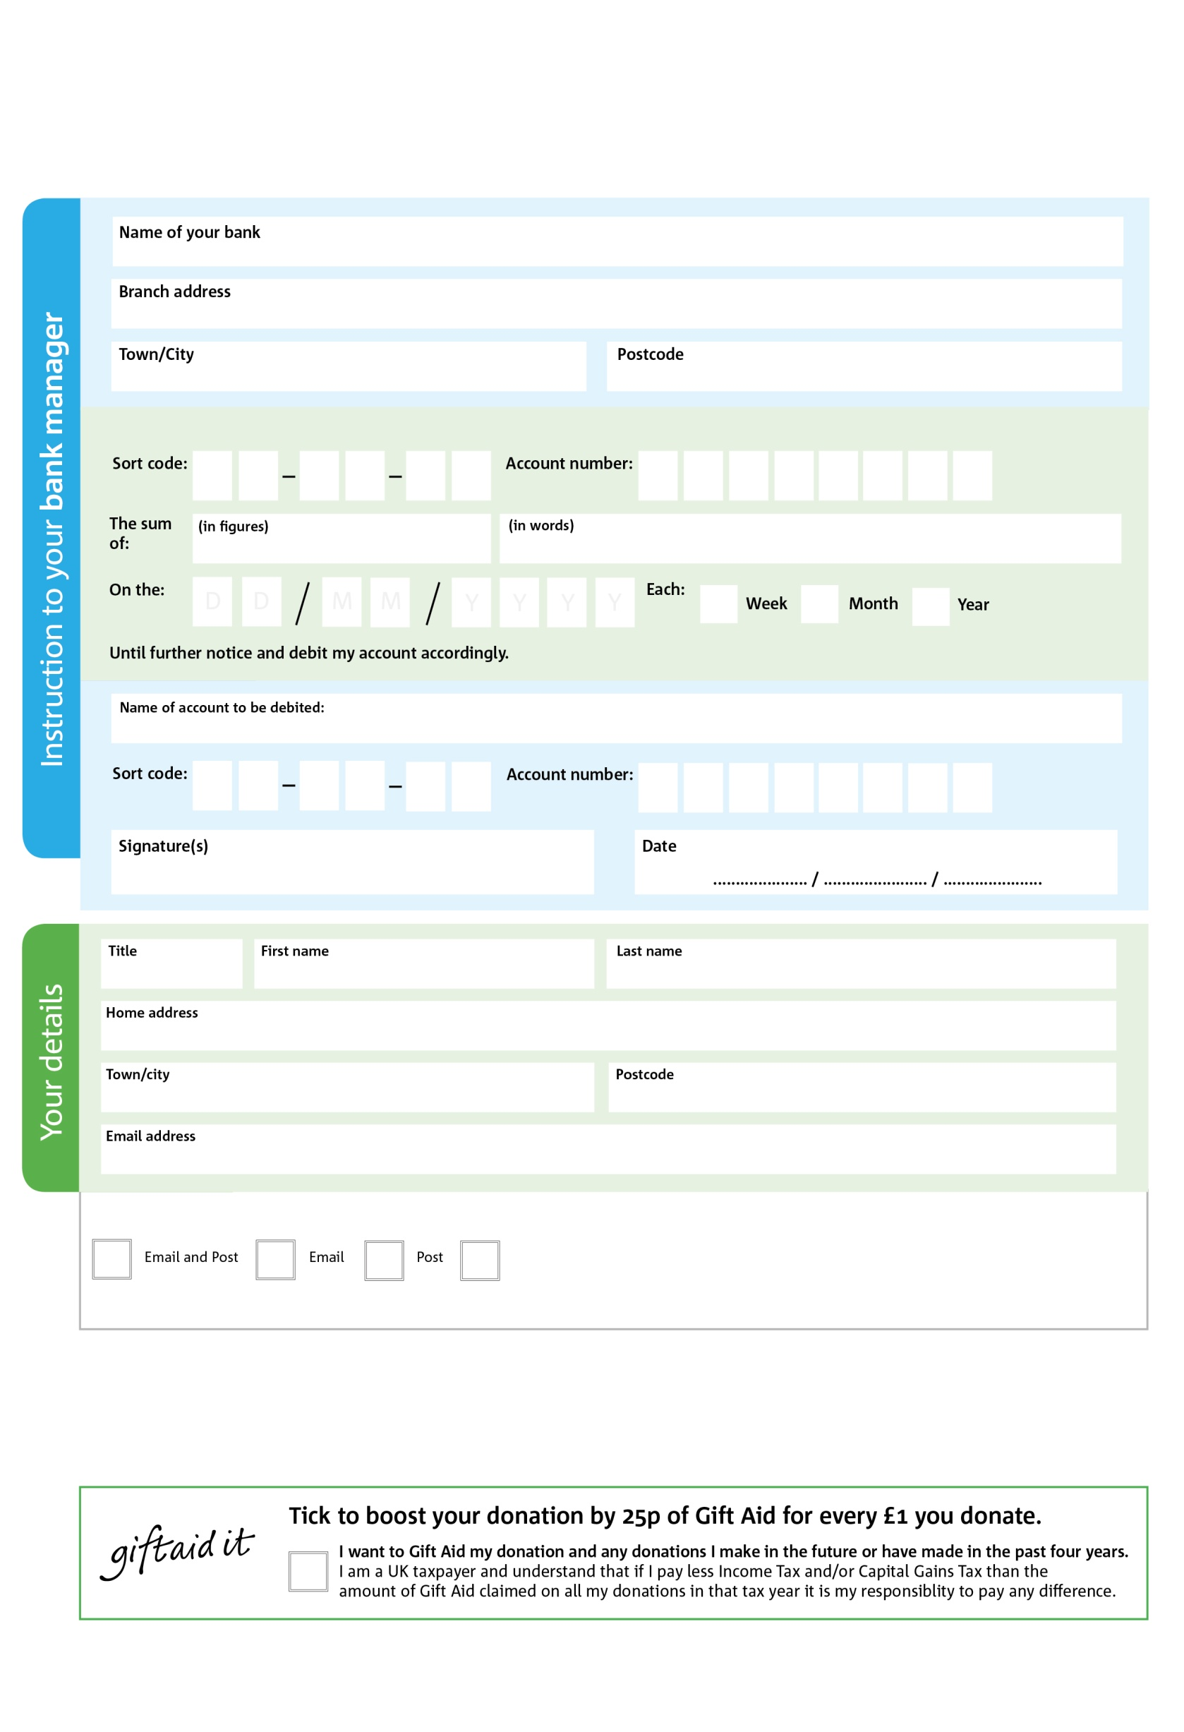

**Please send this form to the foodbank addresss at the bottom of the page.**

**We will save a copy for our records and send the original to your bank or building society.**

Reg. Charity No: 1174426 | Reg. in England & Wales

POSTAL ADDRESS: Chesterfield Foodbank, Unit 3, Carrwood Road Industrial Estate,

Carrwood Road, Sheepbridge, Chesterfield, Derbyshire, S41 9QB

**Data protection**

Chesterfield Foodbank is committed to protecting your privacy and will process your personal data in accordance with the Data Protection Act 1998. Chesterfield Foodbank collects information to keep in touch with you and supply you with information relating to our work. Chesterfield Foodbank will never sell or pass your details to anyone who isn’t directly working on our behalf.

1

V

3

V

4

V

2

V

7 

V

6X

V

5

V

6

V

9

9

2

9

8

0

We would love to keep you up to date with information about Chesterfield Foodbank. Please tick your preference:

You can change your preferences any time by contacting us on 07984 589456 or emailing us at [info@chesterfield.foodbank.org.uk](mailto:info@chesterfield.foodbank.org.uk)

I do not wish to receive future communications from Chesterfield Foodbank

Please pay Chesterfield Foodbank,

**Standing Order Mandate**

**chesterfield.foodbank.org.uk**

You can change your preferences any time by contacting us on XXXXXXXXXXX or emailing us at XXXX@XXXXXXXXXX.foodbank.org.uk

I do not wish to receive future communications from XXXXXX Foodbank